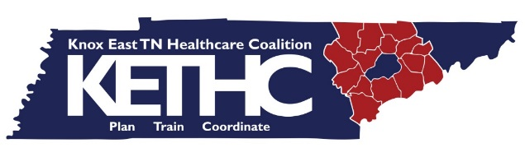 | May Meeting  5/10/2016  2:30 PM  Knox County Health Department Community Room
Agenda
Old Business, Minutes Approval

ZIKA

HRTS Updates

Training Attendance Requirement

Budget
- Final closeout funding

Warehouse Day (May 16, 2:00)

HAM/Winlink Testing

EPFAT Reminder

Upcoming Trainings/Meetings/Exercise Information
- June 8, 2016 Y-12 FSE

Other Info
- Pain Clinic Regulations

Additional Information

